**Process Document: Git and GitHub Workflow**

Link to my GitHub account: https://github.com/matineno/TWS-Repo

**Objective:**

This document outlines the step-by-step process for utilizing Git and GitHub effectively within a development team. By following this workflow, team members can collaborate seamlessly, track changes, and ensure version control throughout the software development lifecycle.

**Prerequisites:**

- Basic understanding of Git version control system.

- Access to GitHub repository and necessary permissions.

**Workflow:**

1. Clone the Repository:

- To begin working on a project, clone the repository from GitHub to your local machine using the `git clone` command followed by the repository URL.

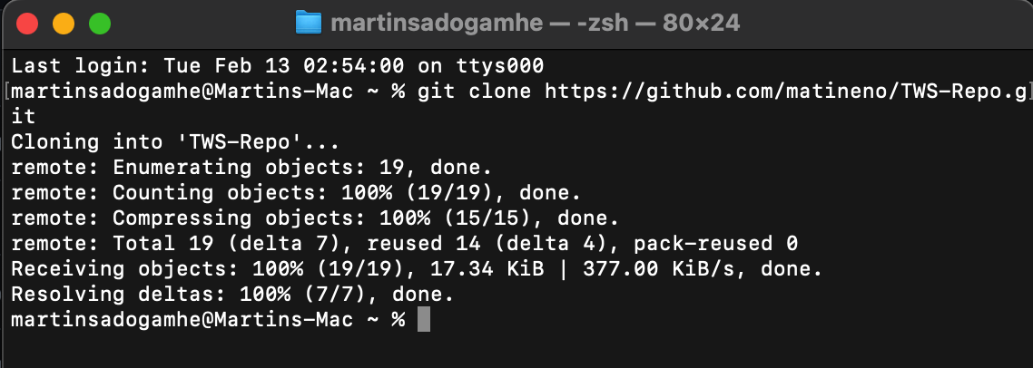

2. Create a Branch:

- Before making changes, create a new branch for the specific feature or bug fix you're working on. Use a descriptive name for the branch to easily identify its purpose.

- Use the `git checkout -b <branch_name>` command to create and switch to the new branch simultaneously.

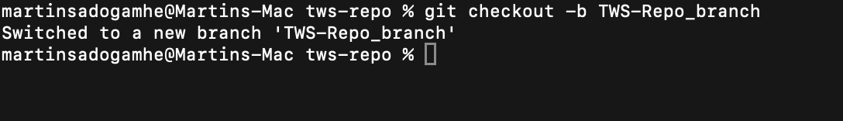

3. Make Changes:

- Make necessary changes to the codebase within your local branch using your preferred code editor or IDE.

- Regularly commit your changes with descriptive commit messages using the `git commit` command.

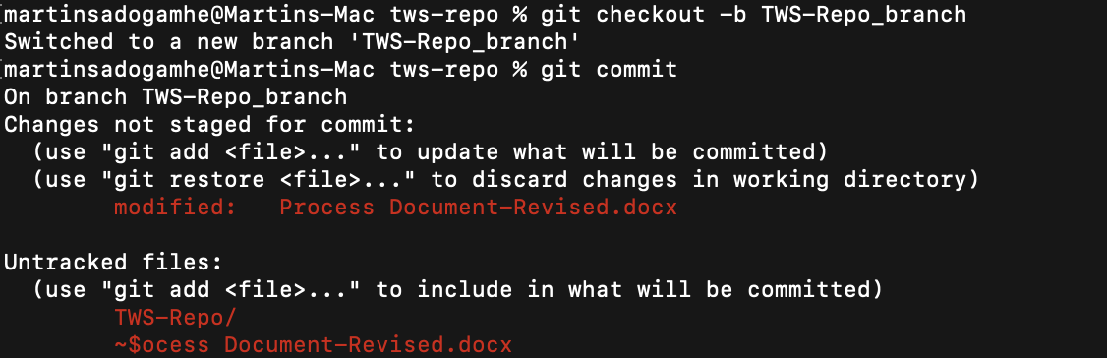

4. Push Changes:

- Once you've completed your changes and committed them locally, push the branch to the remote repository on GitHub using the `git push origin <branch_name>` command.

- This action makes your changes accessible to other team members for review and collaboration.

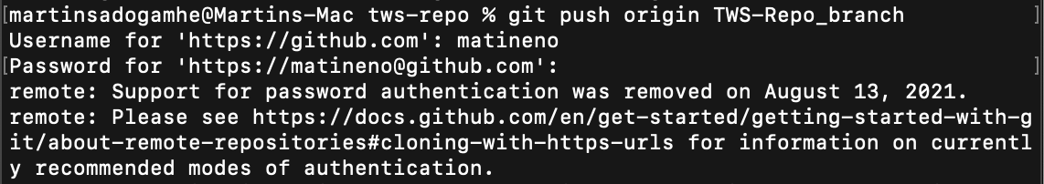

5. Pull Request:

- On GitHub, navigate to the repository and create a pull request (PR) from your branch to the main development branch (e.g., `main` or `develop`).

- Provide a descriptive title and detailed description of the changes included in the PR.

- Assign reviewers and/or team members for feedback and approval.

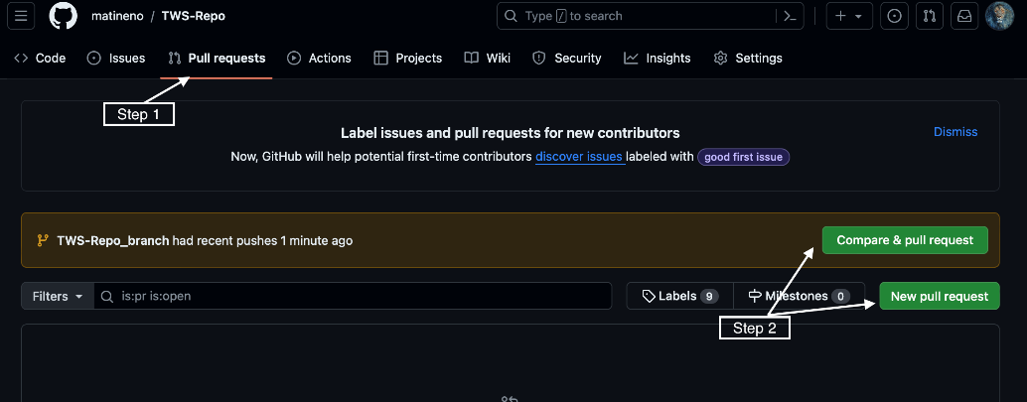

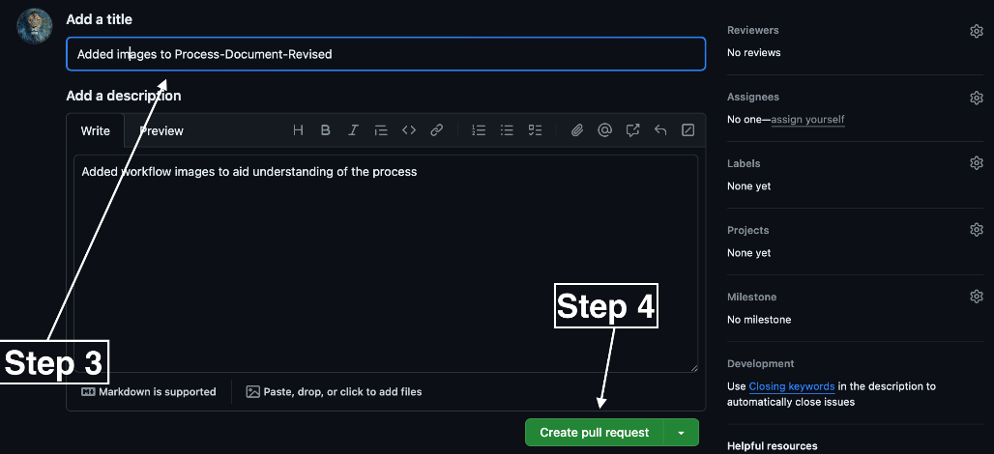

6. Review and Collaborate:

- Team members review the code changes, provide feedback, and discuss any necessary modifications within the pull request conversation.

- Make any requested changes to the code and push updates to the same branch.

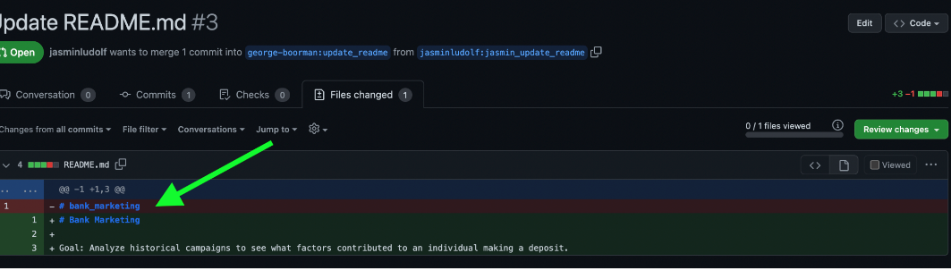

7. Merge Pull Request:

- Once the changes have been reviewed, approved, and any necessary modifications made, merge the pull request into the main development branch.

- Resolve any merge conflicts if they arise and ensure the branch is up to date with the target branch before merging.

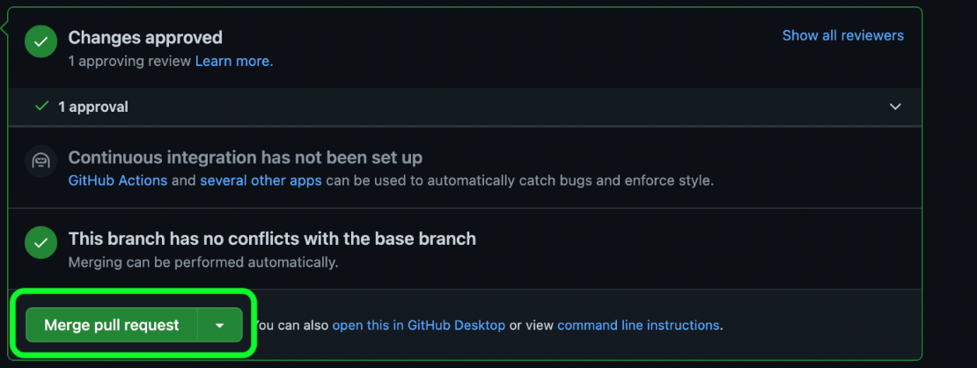

8. Cleanup:

- After the changes have been merged, delete the feature branch both locally and remotely using the `git branch -d <branch_name>` and `git push origin --delete <branch_name>` commands, respectively.

- Keep the local repository up to date with the latest changes from the remote repository using `git pull` regularly.



**Best Practices:**

- Follow a consistent naming convention for branches, commits, and pull requests to maintain clarity and organization.

- Write clear and descriptive commit messages that explain the purpose and rationale behind each change.

- Regularly pull changes from the main development branch to keep your local repository up to date and avoid conflicts.

- Communicate effectively with team members, providing updates on progress, seeking feedback when needed, and resolving issues collaboratively.

By following this Git and GitHub workflow, teams can streamline collaboration, ensure version control, and effectively manage the software development process from start to finish.

**Link to my GitHub account**: https://github.com/matineno/TWS-Repo